Grade 7 Accelerated · Unit 4 · Lesson 1  Adding and Subtracting in Scientific Notation  Independent Set 4.01 | Name______________________  Date______________________  Period____________________

Six questions, on your own, in silence. Show the step that does the work.
1. 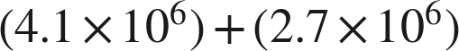

2.

3. 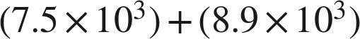

4. 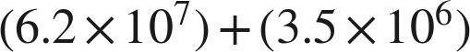

5.

6. Find .

